PEER REVIEW IN OSTRAVA
Hybrid workshop (link connection Skills+ Peer Review Ostrava April 27/28 2022)
April 27, 2022, from 16:00 to 19:00
April 28, 2022, from 9:00 to 12:00
Venue: Regional Chamber of Commerce of the Moravian - Silesian Region
Výstavní 8, CZ - 709 00 Ostrava-Mariánské Hory a Hulváky
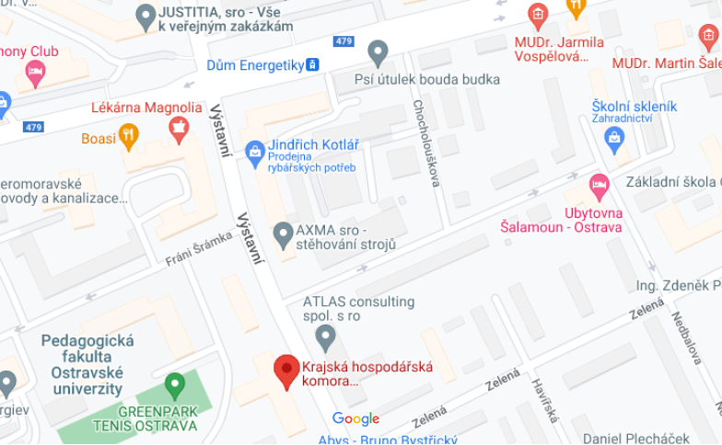 | 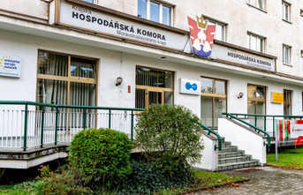

April 27, 2022, from 17:00 to 19:00
17:00 – 19:00 Registration of participants
17:10 – 19:30 Preliminary discussion about the project Skills+ Peer Review

April 28, 2022, from 9:00 to 12:00
09:00 – 09:10 Registration of participants
09:10 – 09:30 Welcome - Open the peer review (D. Juchelková, other representant Skills+ TBC)
09:30 – 10:00 Project Introduction, expectation, short result (D. Juchelková)
10:00 – 10:30 IT and Digitalization in MSk Region (KHK MSk – TBC)
10:30 – 10:50 Coffee break
10:50 – 11:05 Rychla Rada presentation MSk Region (J. Skipala)
11:05 – 11:20 Potential for Smart Villages in our Region (D. Juchelková)
11:20 – 12:00 Stakeholder discussion with the Peer Review team (all)
12:00 – 13:30 Working Lunch (summarization of recommendation)
From 13.30 Afternoon section (Facultative)
Excursion TUO (www.vsb.cz/en),
Discussion MSCI (https://ms-ic.cz/en/about-us/)

Focus: Skills+ Action Plan, good practices
Contact: dagmar.juchelkova@vsb.cz; +420 602 501 243

