REGIONAL BUSINESS FORUM
November 10th, 2020, Novi Sad, Serbia
3rd REGIONAL BUSINESS FORUM

The Autonomous Province of Vojvodina and Assembly of European Regions, in cooperation with the Chamber of Commerce and Industry of Vojvodina, Vojvodina Development Agency and Enterprise Europe Network are organising the Third Regional Business Forum to be held on November 10th 2020. This Regional Business Forum will be organised in an online setting and it will be possible to follow the event online in real time. The conference will be organised with maximum health safety measures, respecting all applicable epidemiological measures prescribed.

The Forum participants will include eminent regional companies, as well as regional chambers of commerce, regional development agencies and/or other institutions supporting SMEs development and enhancing business and investment climate.

The Regional Business Forum will provide the companies with an opportunity to express and present their business potentials and ideas, and connect with other companies and institutions supporting SME development and new investments.

The international forum provides additional support to companies to find international partners. The participants will have an opportunity to schedule and hold B2B meetings with companies and institutions participating in the Forum, according to their own needs, based on the information about the registered participants.

The sectors that will be represented are:
- Agriculture and Food Industry
- Construction Industry
- ICT and Creative Industry

The B2B platform is available at https://rbf2020novisad.talkb2b.net/, providing the possibility to promote business cooperation between regions, including agreements on free trade and production, joint projects, i.e. joint ventures and joint access to third markets, as well as the exchange of technologies and know-how and cooperation in projects characterised by a high degree of competitiveness and innovation, funded by the EU and other donors.

For additional information please visit rbf.vojvodina.gov.rs or contact: rbf2020@vojvodina.gov.rs

 |  |  | 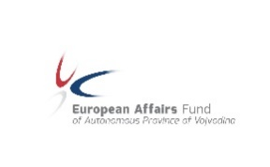 | 