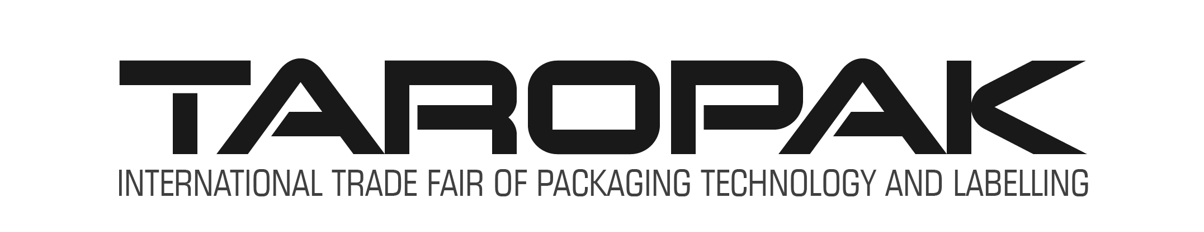Poznan, Poland 30.09 – 03.10.2019

TAROPAK is the largest forum for presenting the latest technological solutions in the packaging industry in this part of Europe. Collecting several hundred exhibitors each time, an event arranged in modern pavilions, from the beginning enjoys enormous interest of visitors. The fair gives the opportunity to learn about new products and observe trends in the packaging industry, both in terms of production, materials used, as well as design and application. Thanks to the rich offer of accompanying events, participants have the opportunity not only to meet in a business setting, but also to take part in conferences, workshops or lectures; The fair is also the place of presentation of the packaging distinguished in competitions promoting innovative projects, distinguished by design and ingenuity. During the 2018 edition, Taropak was visited by 42640 professionals from the industry, the exhibition area covered over 25,000 square meters, where 430 exhibitors from 19 countries presented themselves.

This year it’ll be held in 30.09. - 03.10.2019

The Taropak thematic area:
Packaging (raw materials and semi-finished products, packaging systems, packaging materials - aluminum, sheets, foils, laminates, paper, sieves, cardboard, textiles, cardboard); Packaging of cardboard, textiles, paper, glass, metal and plastics; Packaging for e-commerce; Labels and labeling systems; Dust covers, wraps, adhesives, ropes, cords, tapes, protective materials, self-adhesive paper and foils, clips, clips, staples, self-adhesive tapes, box and box equipment, closures and other packaging; Machines and equipment for packaging, machines for the production of packaging, labeling and marking machines, services, specialist publications.

