S E R B I A

PROFILI FIRMI KOJI NASTUPAJU NA SAJMU
TECH AGRO – BRNO, 08.-12. Aprila 2018

- Agromerkur Ltd, Ada, Street Industrijska 10, Serbia

Family-owned company specialized in the production of machine tools and spare parts foragricultural machinery (combiners, combiners, inter row cultivators, deep subsoilers, cambridge rollers itc). Agricultural machinery is made basedon expectations of farmers, assembled by professionals and of high quality materials.
Each machine has a plastic coating on (powder paint), to be fully preserved from corrosion and has a long life durability.
Have a certificate : CE mark and ISO 9001
Contact:
+381 24 853 232
agromerkur@eunet.rs
www.agromerkur.com

- Ati Terming Ltd, Kula , Street Kucurski put bb, Serbia

Terming Ltd is established in 1996.The main products are: boilers based on straw and
biological materials derived from plants used for heating of individual houses, workshops, halls, farms, kilns, and greenhouses.
Also, in each of these areas the company offers equipment with its own technological solutions:
• Equipment for pig farm
• Construction of greenhouses, heating installations in greenhouses
• Batch dryers for grains
• Heat accumulators, tanks
• Solar panels, water heaters,
• Stainless steel and steel chimneys
The company also produces TERMOGENI - hot air generators and boilers for agropelet - pellets of agricultural residues - straw, corn, sunflower seed shells and their waste from agriculture in granulation up to 10 mm.
Have a certificate : ISO 9001 ; CE mark

Contact:
+381 25 722 233
+381 25 726 870
termingkula@gmail.com
www.termingkula.rs

- Kizi Metal Ltd, Čurug, Street Jovana Sterije Popovića 25a, Serbia

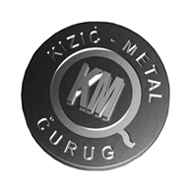

Kizic-metal Ltd. is a family business that was established and started operations in 2005. The company has about 500 m² production and about 250 m² of office space. A wide range of modern machines, which the company has available, enabling quick and easy transformation of the production program and meet the various demands of customers.
Today Kizic Metal Ltd. is a modern company, personnel and technologically well-equipped, facing the future, and their business achieve through the following activities:
• Production of perforated sheet-metals - various materials of thickness from 0.5mm to 6mm.
Perforation can be with round, square, elliptical, rectangular, triangular, puzzled, hexagonal,
oblong, combined with decorative holes, hole sizes shapes according to customer;
• Production of metal products - shelves for warehouses, clothes wardrobes, archive boards,
cabinets for weapons, parts of metal structures, etc.
• Production bonds in construction - brackets and fittings for doors and windows
• Production and installation of prohronskih gates and fences - stainless steel gates and fences
• Production and installation of gates and fences made of wrought iron
• Production of mobile equipment - benches, chairs, cans, baskets, bicycle storage room,
partition columns, pedestrian barriers, masts
• Production of equipment for workshops - workshop tables, workshop stands, industrial
truck
• Production and installation of playgrounds - slides, swings, seesaws, etc.
• Production and installation of sports equipment -
basketball structure, goals, gymnastic equipment-shaft, loom
• Production of goods for special purpose - grills for walkers and household , stable solid-barbecue-different designs-intended for roasting pigs,
lambs, chickens, etc.
• Production of boilers for central heating installation in tiled stoves

Contact:
+381 21 833 489
+381 21 835 491
k-metal@neobee.net
www.kizicmetal.co.rs

- Agroferocoop Ltd, Temerin, Street Novosadska 333, Serbia

The company began its work as a machine workshop and later on developed into company
with wide range of activities. New production programs were introduced such as: pallet forklifts, freight elevators, and at the beginning of 2000 it was expanded to agricultural machinery (trailed and mounted harrows, seed bad preparing combination, manure loaders…).
Besides the production, company is also a dealer of other producers of agricultural machinery from Japan, Croatia, Italy. Agroferocoop represent company Polnistroje ( www.polnistroje.cz) and they sold a lot of things.

Have a certificate : ISO 9001 and CE mark

Contact:
+381 21 843 932
www.agroferocoop.rs
agroferocoop@gmail.com

- Agrometal BMR Ltd, Sombor, Street Rokovački put bb, Serbia

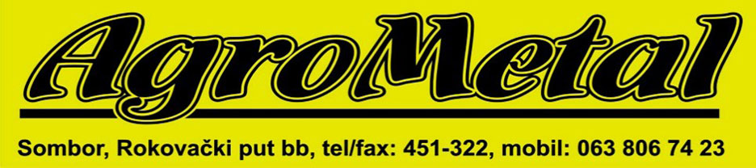

BMR „Agrometal” was founded in 1991. The main activity is the production of metal constructions, tractor sprayers for pesticides, implements for the seedbed preparation, silo equipment, metal halls and other devices in agriculture:
• Production of agricultural sprayer,
• Production of seed bad preparing combination,
• Production of silo equipment and facilities,
• Production of metal structures,
• Services of cutting, bending and machining of steel,
• Sales service and repair of agricultural machinery and silo equipment.

Have a certificate : ISO 9001

Contact:

+381 25 451 322
caricsven@open.telekom.rs
www.agrometal-rs.com

- Agria Ltd, Subotica, Street Bajski put 177, Serbia

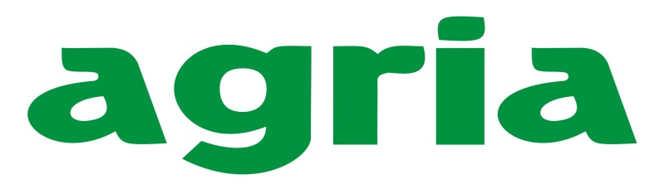

Agria was established in 1989 as a workshop for the manufacture of parts and machines. In 1993 it changed into a company and its profile turned towards thdevelopment of machine parts. Since 1995 the company has developed production process of its own agriculture machines. The production of complete agriculture machinery has started and the company has reached significant participation in the market. Parallel with strengthening position in domestic market, the company strengthens its position in foreign markets. The main product is pneumatic multi-row seed for wheat, corn, sunflower and vegetables.
Have a certificate : ISO 9001

Contact:
+381 24 561 553
office@agria.rs
www.agria.rs

- IQ Patent Ltd, Subotica, Street Gornji Verušić 101

IQ Patent was foundedwith the desire to transform it’sexperiense in grouing crops into innovative machinery for farmers who want to improve their production.Our focus is on continuous improuement of the existing technology and introduction of new ones in order to increase the quality and officiency of our machines.IQ Patent designs and converts customer needs into functional machinery.

Contact:
+381 64 30 64 782
bojanpatent@gmail.com
www.iq-patent.com

